水平极化
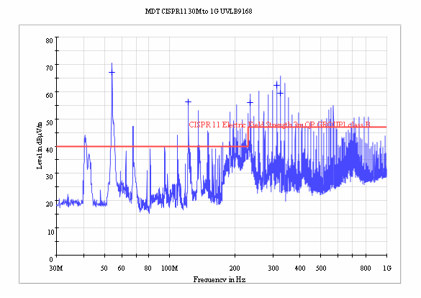
Limit and Margin QP
Frequency  (MHz) | QuasiPeak  (dBµV/m) | Meas. Time  (ms) | Bandwidth  (kHz) | Height  (cm) | Polarization | Azimuth  (deg) | Corr.  (dB) | Margin  (dB) | Limit  (dBµV/m)
54.250000 | 67.2 | 1000.0 | 120.000 | 180.0 | H | 134.0 | 14.1 | -27.2 | 40.0
122.050000 | 56.4 | 1000.0 | 120.000 | 180.0 | H | 233.0 | 13.7 | -16.4 | 40.0
236.000000 | 55.9 | 1000.0 | 120.000 | 112.0 | H | 226.0 | 13.3 | -8.9 | 47.0
311.900000 | 62.4 | 1000.0 | 120.000 | 139.0 | H | 0.0 | 15.3 | -15.4 | 47.0
325.486250 | 59.3 | 1000.0 | 120.000 | 139.0 | H | 0.0 | 15.8 | -12.3 | 47.0

(continuation of the "Limit and Margin QP" table from column 17 ...)
Frequency  (MHz) | Comment
54.250000
122.050000
236.000000
311.900000
325.486250

垂直极化
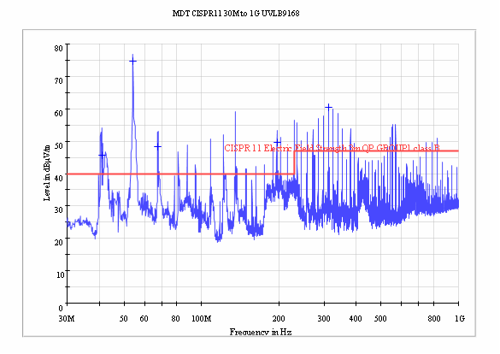

Limit and Margin QP
Frequency  (MHz) | QuasiPeak  (dBµV/m) | Meas. Time  (ms) | Bandwidth  (kHz) | Height  (cm) | Polarization | Azimuth  (deg) | Corr.  (dB) | Margin  (dB) | Limit  (dBµV/m)
41.050000 | 45.7 | 1000.0 | 120.000 | 100.0 | V | 26.0 | 14.7 | -5.7 | 40.0
54.250000 | 74.8 | 1000.0 | 120.000 | 100.0 | V | 26.0 | 14.1 | -34.8 | 40.0
67.700000 | 48.3 | 1000.0 | 120.000 | 100.0 | V | 26.0 | 12.2 | -8.3 | 40.0
196.600000 | 49.6 | 1000.0 | 120.000 | 100.0 | V | 26.0 | 11.8 | -9.6 | 40.0
311.900000 | 60.4 | 1000.0 | 120.000 | 100.0 | V | 26.0 | 15.3 | -13.4 | 47.0

(continuation of the "Limit and Margin QP" table from column 17 ...)
Frequency  (MHz) | Comment
41.050000
54.250000
67.700000
196.600000
311.900000

